Create a table named Managers with fields : Manager_Id First_name Last_Name DOB Age ->Use check constraint Last_update Gender Department Salary -> NOT NULL

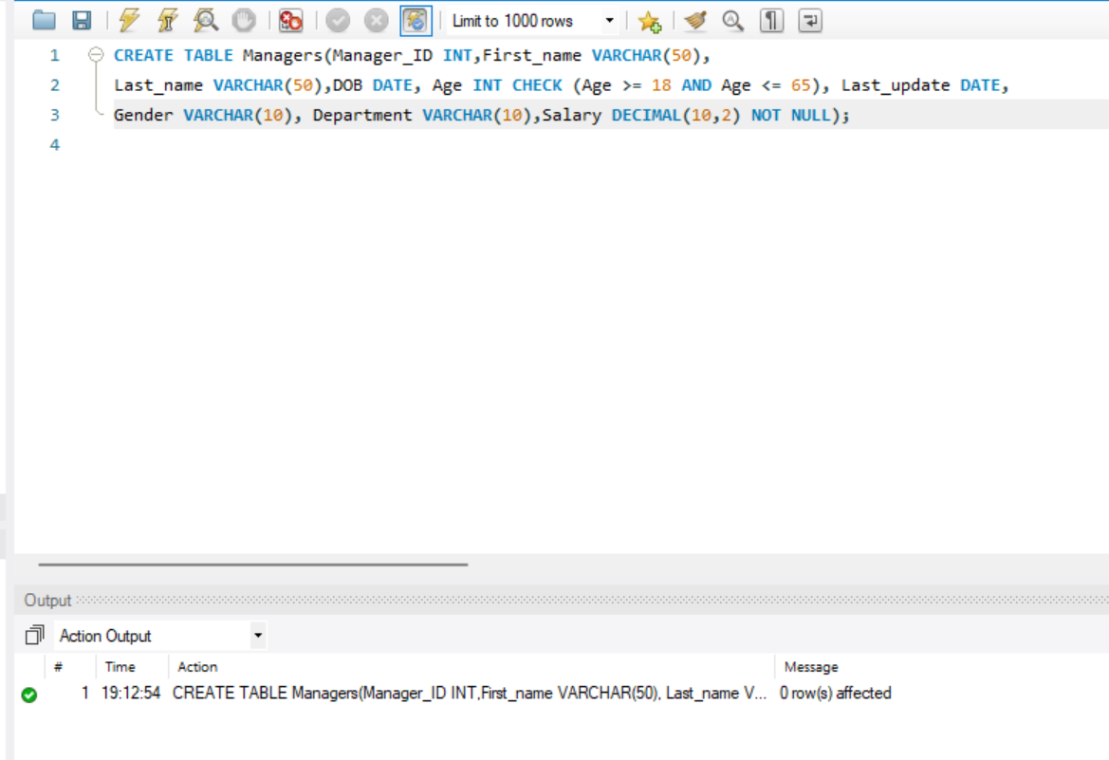

1)Insert 10 rows.

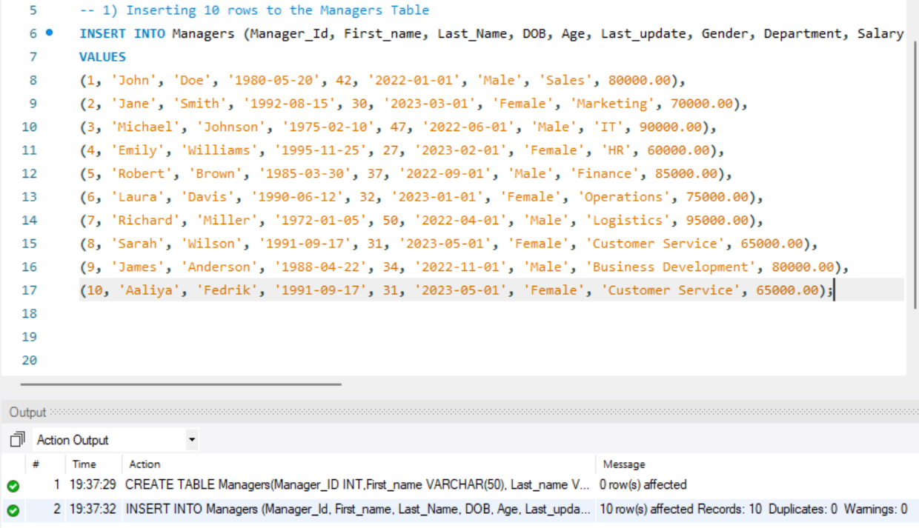

2)Write a query that retrieves the name and date of birth of the manager with Manager_Id 1.

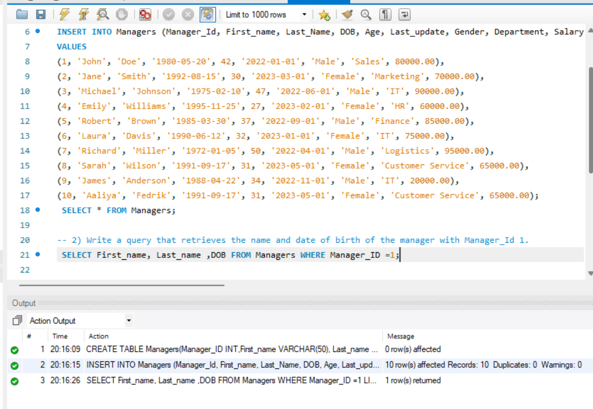

3) Write a query to display the annual income of all managers

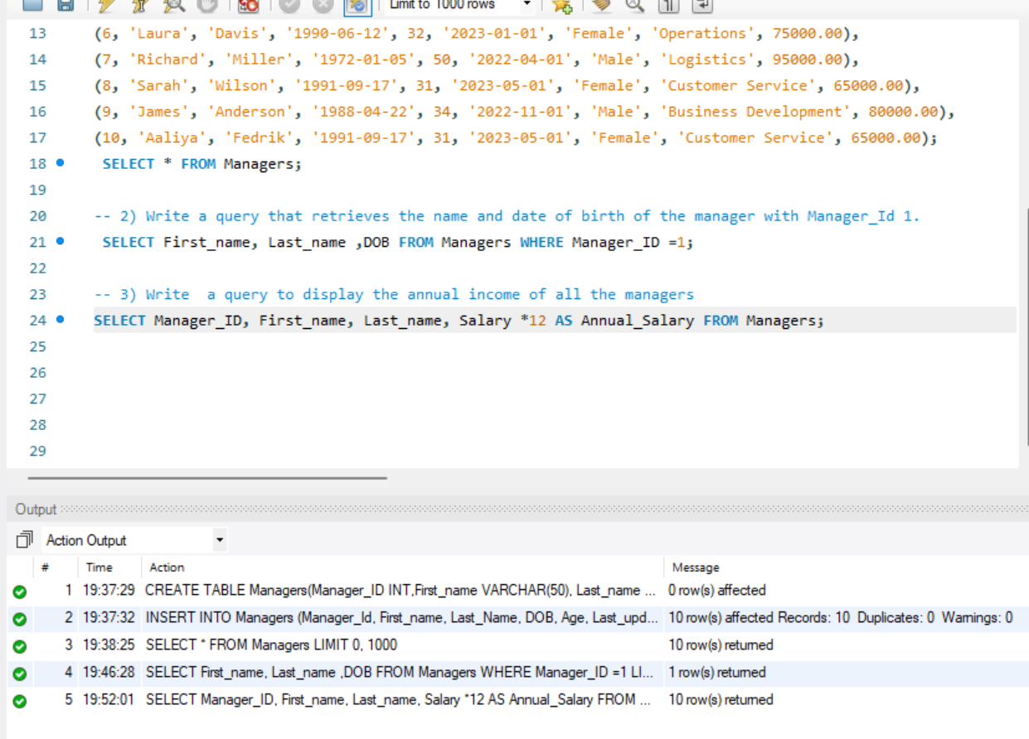

4) Write a query to display records of all managers except ‘Aaliya’.

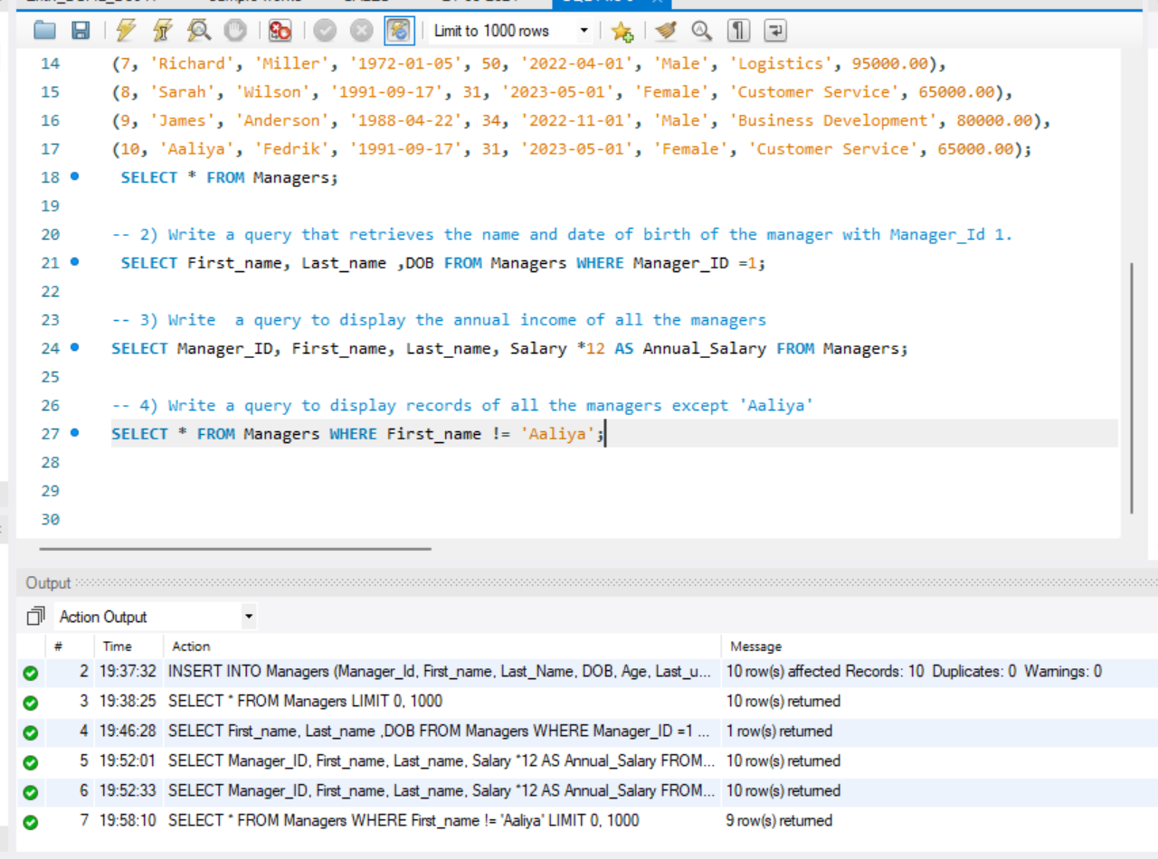

5) Write a query to display details of managers whose department is IT and earns more than 25000 per month.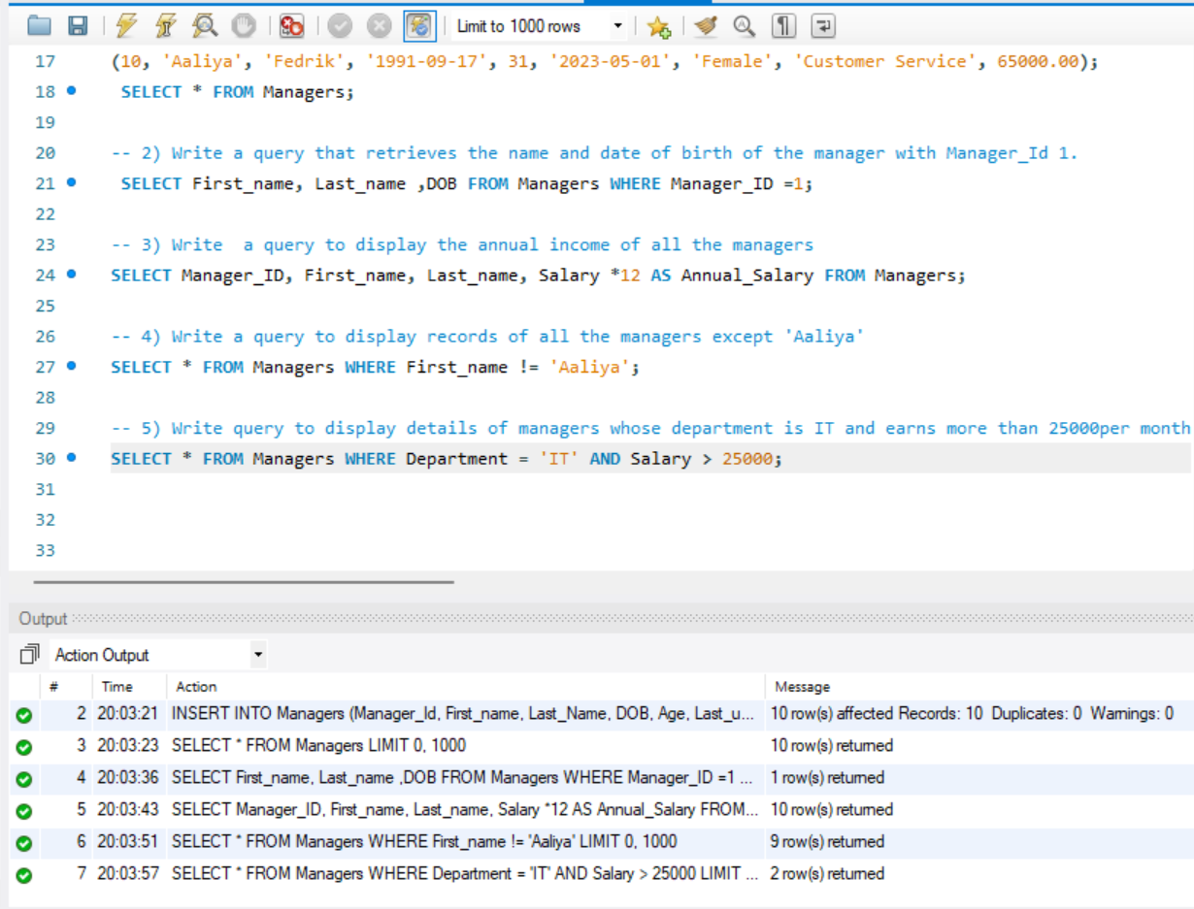

6) Write a query to display details of managers whose salary is between 10000 and 35000.

